19.22: a)

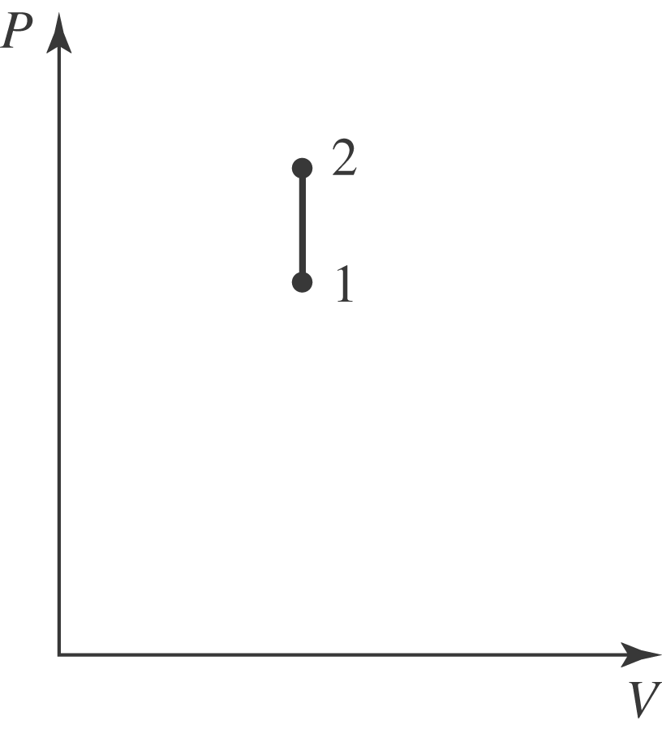
b)

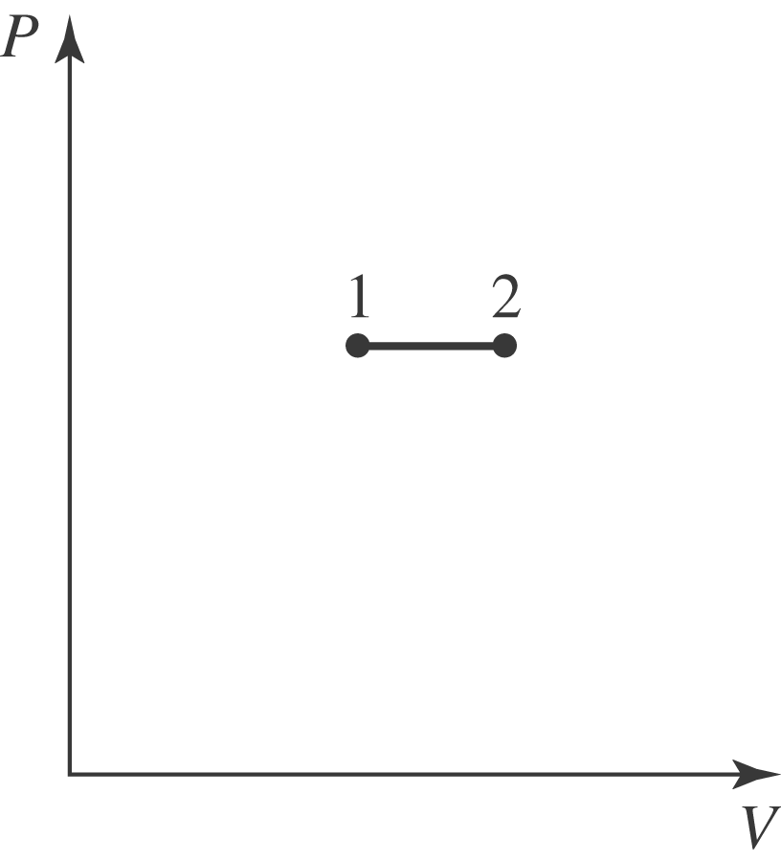

- In the first process, is the same for both, and so Q is larger for the second. d) For an ideal gas, 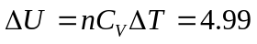 J for both parts (a) and (b).

